**SOLUTION ARCHITECTURE**

[SKILL JOB RECOMMENDER APPLICATION](https://github.com/IBM-EPBL/IBM-Project-17692-1659675303/tree/main/SKILL%20JOB%20RECOMMENDER%20APPLICATION)

**TEAM ID: PNT2022TMID37370**

**Team Members:**

1. Barathraj
2. Kasinathan
3. Santhoshkumar
4. Vignesh ram

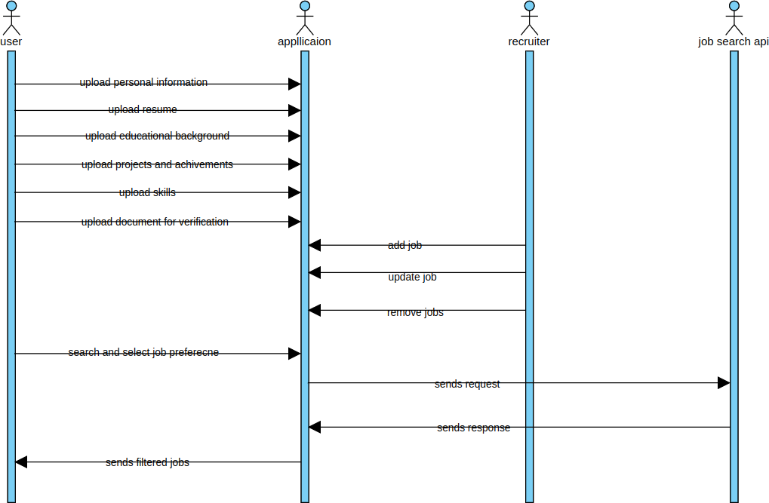

## Sequences Diagram of [SKILL JOB RECOMMENDER APPLICATION](https://github.com/IBM-EPBL/IBM-Project-17692-1659675303/tree/main/SKILL%20JOB%20RECOMMENDER%20APPLICATION)